**DESKTOP PUBLISHING APPLICATIONS**

**PROCEDURES**

* Review the event guidelines below
* Demonstrate basic skills in the areas of desktop publishing and creativity and be prepared to:
  1. Create, design, and produce usable copy on a computer using desktop publishing software
  2. Flyer
  3. Brochure
  4. Invitation that include graphics, text, layout creativity, and appropriate fonts and type sizes
* This event can be individual or a team of up to three (3) members
* One computer is used
* Participants may bring clip art or use the Internet to access graphics
* Finished project must be submitted in black and white
* Word division manuals and dictionaries may be used as reference materials for this event (I would use online dictionaries)
* 45 minute skills test at school site

**RESOURCES**

* FBLA-PBL [www.fbla-pbl.org](http://www.fbla-pbl.org)

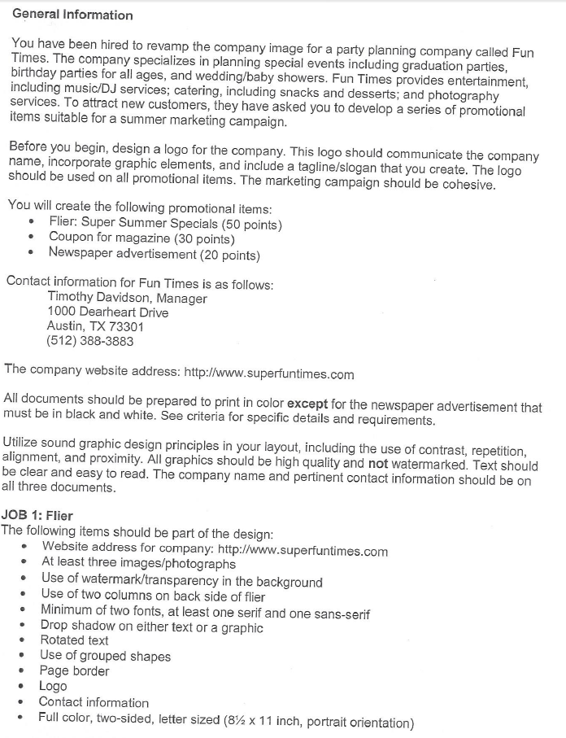

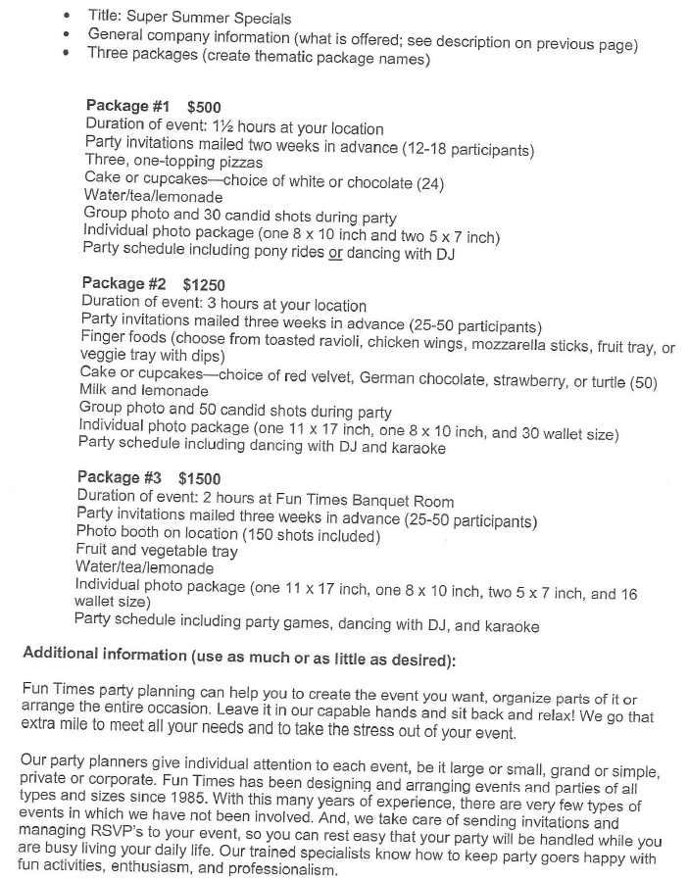

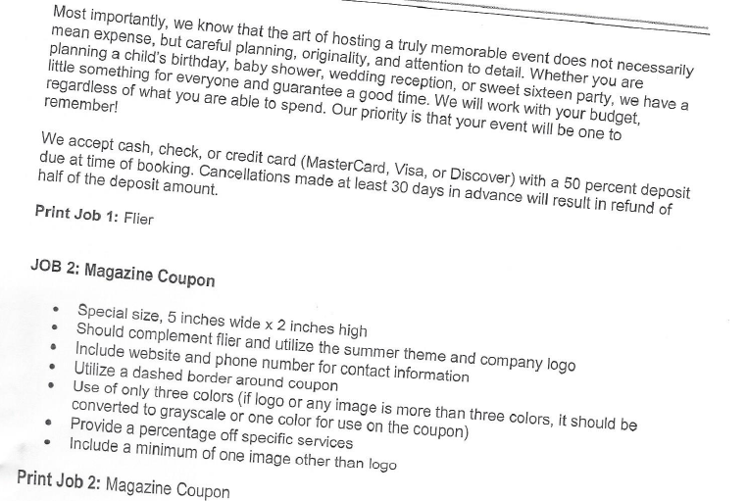

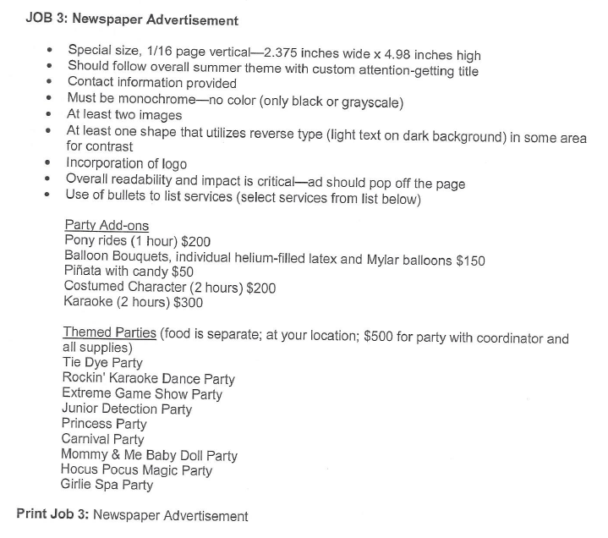

**ML – DESKTOP PUBLISHING APPLICATION**

RATING SHEET

|  |  |  |  |  |  |
| --- | --- | --- | --- | --- | --- |
| **Evaluation Item** | **Not**  **Demonstrated** | **Does not Meet Expectations** | **Meets**  **Expectations** | **Exceeds**  **Expectations** | **Points**  **Earned** |
| **Overall Appeal** | | | | | |
| Presentation immediately grabs audience | 0 | 1-3 | 4-7 | 8-10 |  |
| Content effectively covers topic with all the vital information—who, what, when, where, why, and how | 0 | 1-3 | 4-7 | 8-10 |  |
| Presentation appeals to intended audience | 0 | 1-3 | 4-7 | 8-10 |  |
| **Layout** | | | | | |
| Layout is creative and original | 0 | 1-3 | 4-7 | 8-10 |  |
| Text and graphics are well-balanced with no overlapping items that reduce readability | 0 | 1-3 | 4-7 | 8-10 |  |
| Graphics are appropriate to subject and are effectively utilized | 0 | 1-3 | 4-7 | 8-10 |  |
| Font selection (type, size, style, kerning, leading, number of typefaces) is appropriate and appealing | 0 | 1-3 | 4-7 | 8-10 |  |
| **Technical Features** | | | | | |
| Effective application of a special effect(s) may include but, not limited to, drop caps, shadowing, reverse type, screens, and mirror images | 0 | 1-3 | 4-7 | 8-10 |  |
| Effective text treatment (i.e. paragraph indents, bullets, numbering, hanging indents, alignment, text wrapping) | 0 | 1-3 | 4-7 | 8-10 |  |
| Proper use of grammar, spelling, punctuation, etc. | 0 | 1-3 | 4-7 | 8-10 |  |
| **TOTAL POINTS** |  |  |  | **/100 max** |  |

Name:

School:

Judge’s Signature: Date

Judge’s Comments: